**Configure VPN between Mumbai and Ohio Lab 4 of 4**

Go to Ohio region, to view the public ip for the network interface (18.218.11.25)

Select security group we need to allow all traffic for 10.0.0.0/16 subnet.

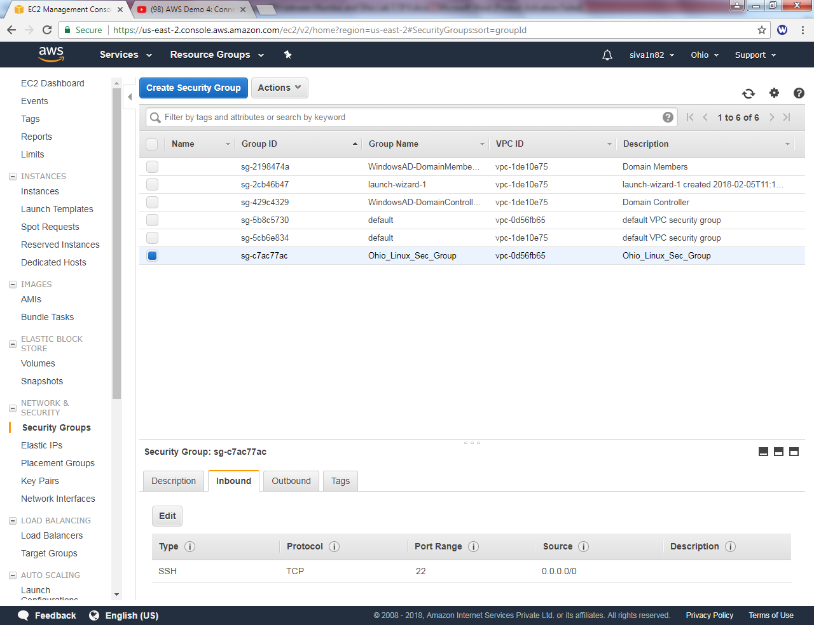

Click Add rule and allow All traffic type source as 10.0.0.0/16 subnet then click “Save”.

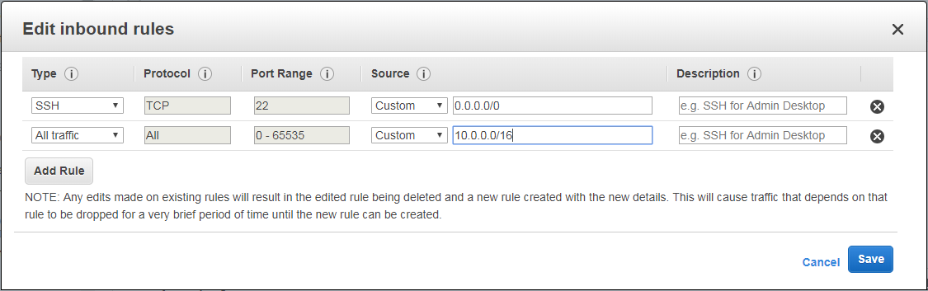

Go to Putty key gen installed in your local machine.

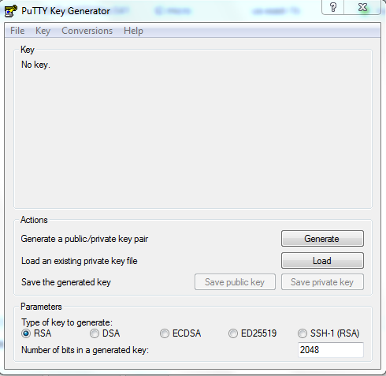

Locate the file and click “Open”.



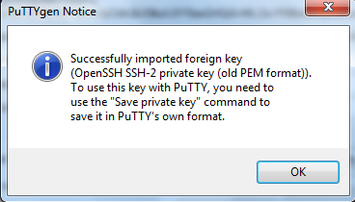

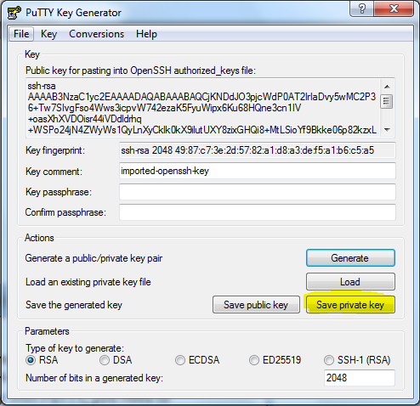

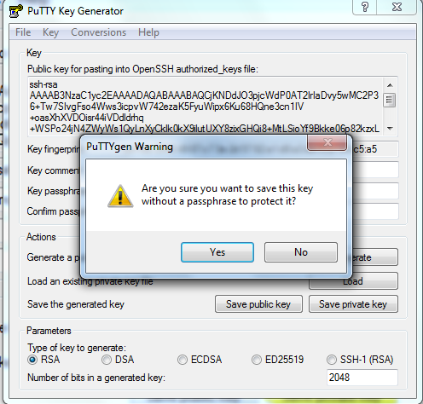

Locate the file to save.

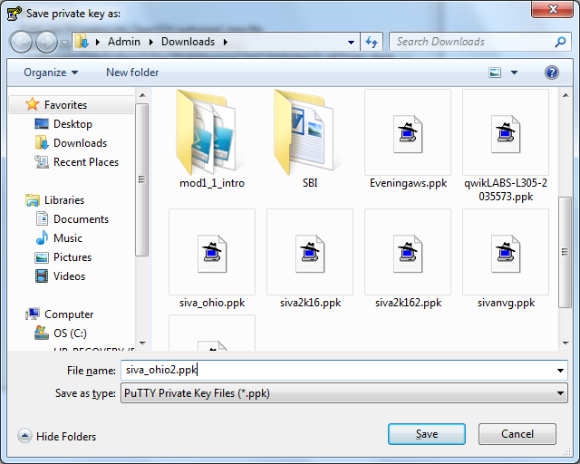

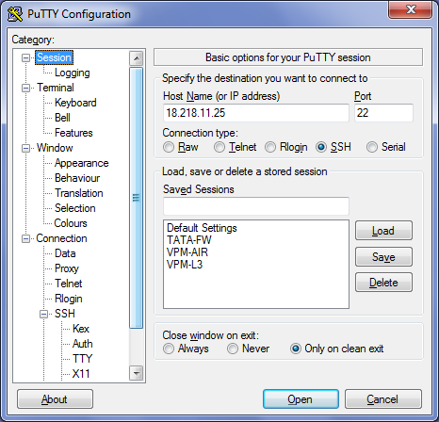

Click Browse and locate the *.ppk file.

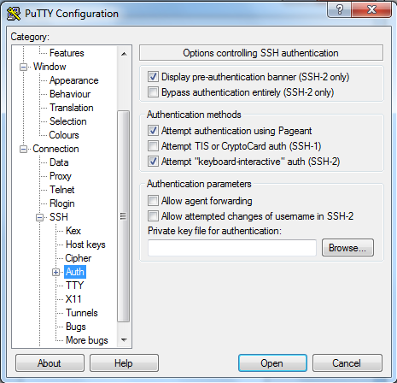

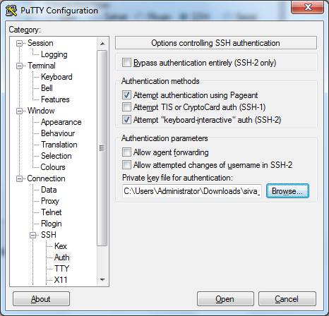

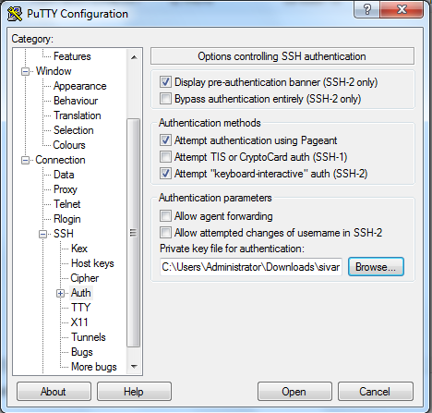

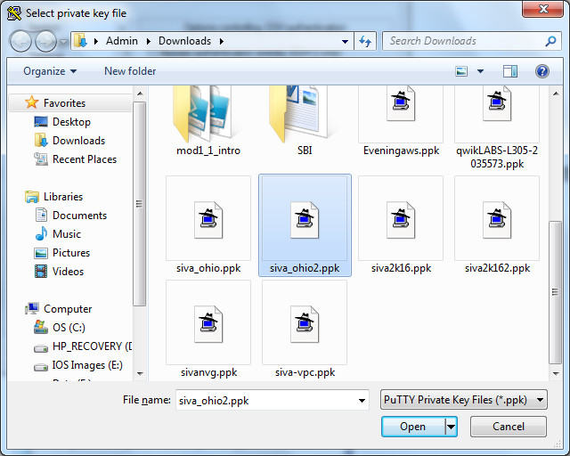

Select the file and Click “Open”.

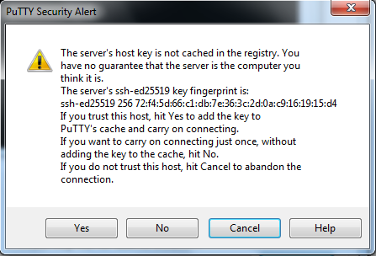

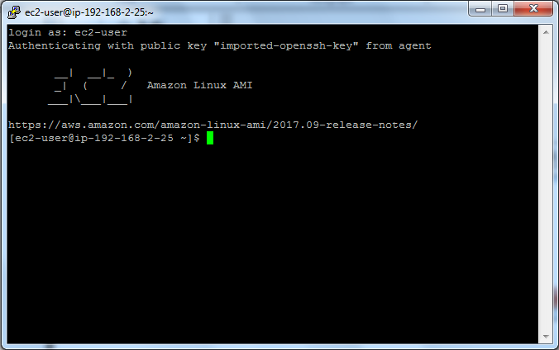

Type

Sudo -i

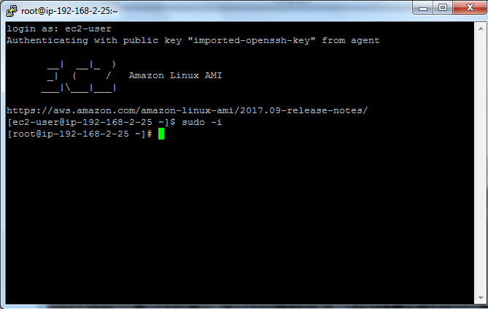

Type

Yum update –y

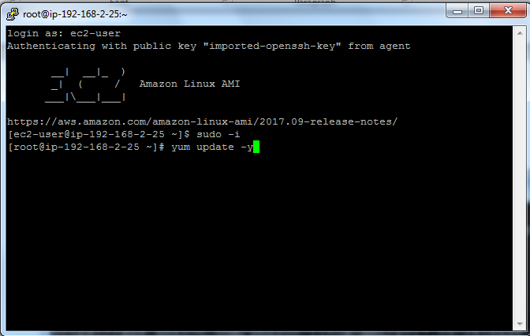

Type

Yum install openswan -y

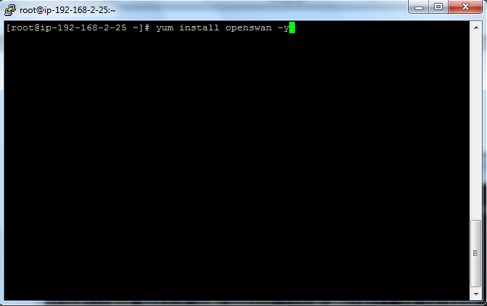

Open swan has been successfully installed.

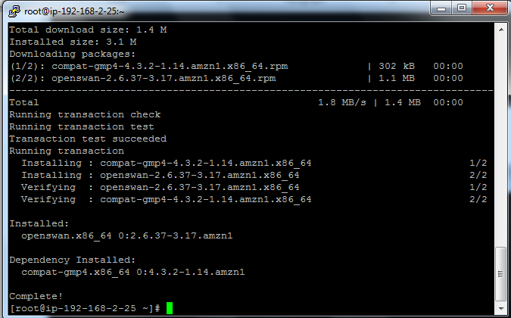

Type

***Vi ipsec.conf***

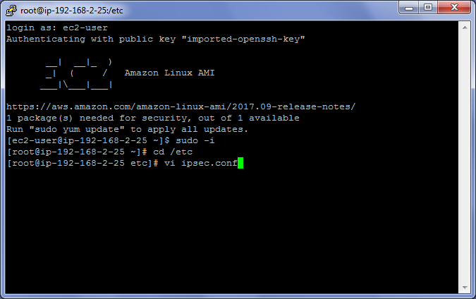

Press insert and remove # from #include /etc/

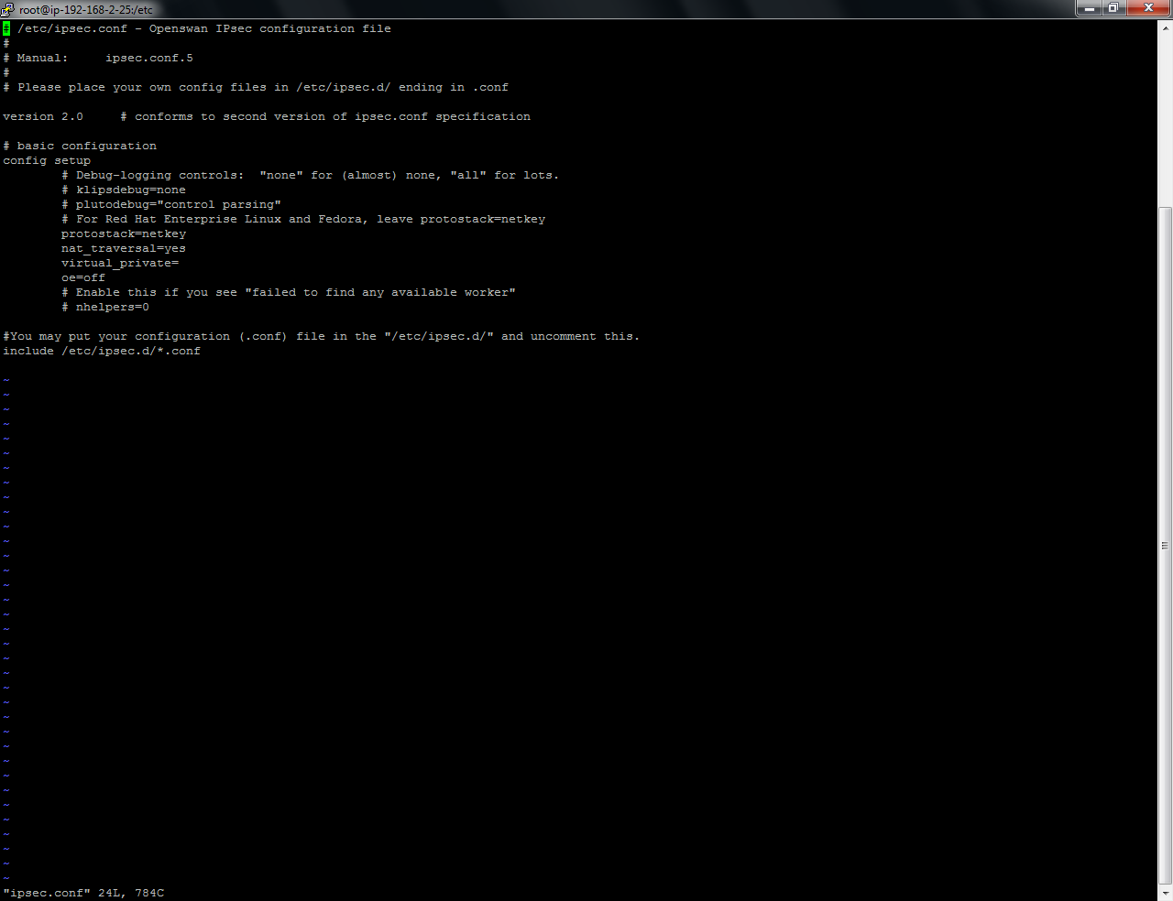

Press ecape and type

:wq

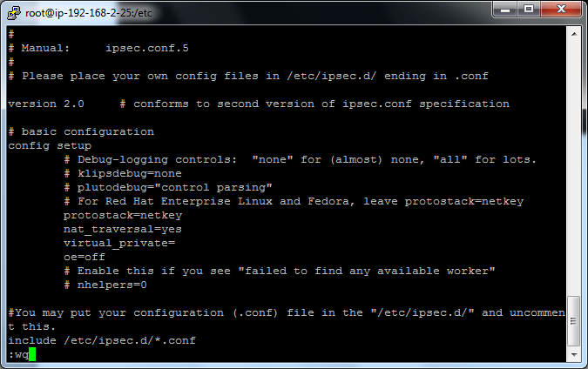

Type

Vi ipsec.d/ohio-to-mum.conf

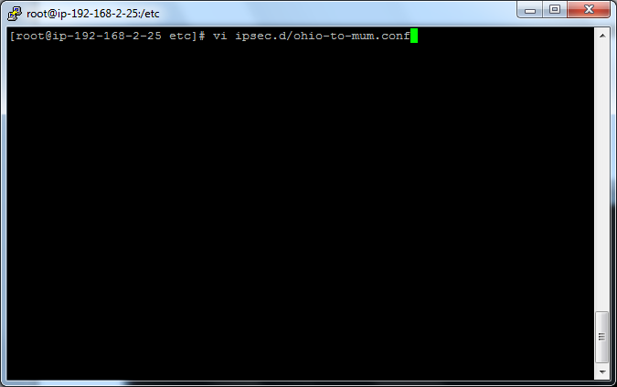

Press Insert key and type the command in vi editor

conn ohio-to-mum

type=tunnel

authby=secret

left=defaultroute

leftid=18.218.11.25

leftnexthop=%defaultroute

leftsubnet=192.168.0.0/16

right=13.127.161.231

rightsubnet=10.0.0.0/16

pfs=yes

auto=start

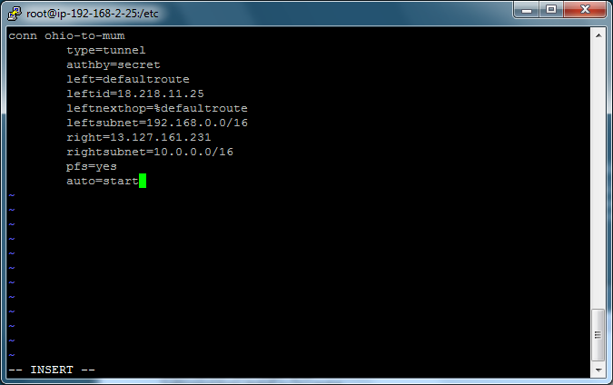

Press escape and type

:wq

Type

Vi Ipsec.d/ohio-to-mum.secrets

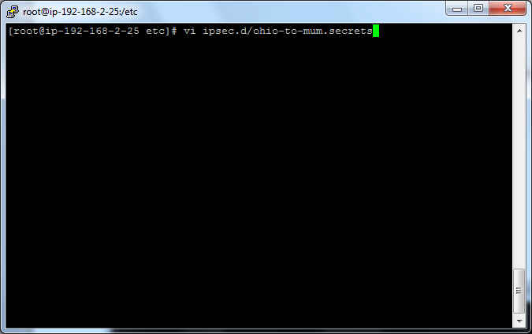

Preshared key is “Sansbound”

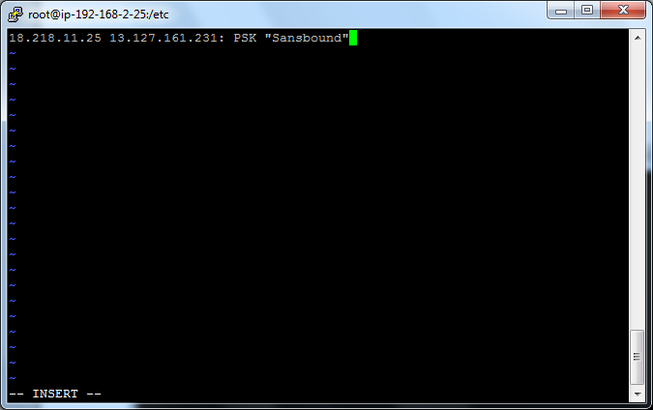

Press escape and type

:wq

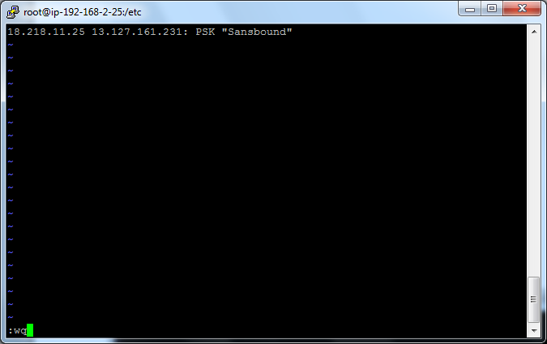

Type

service ipsec start

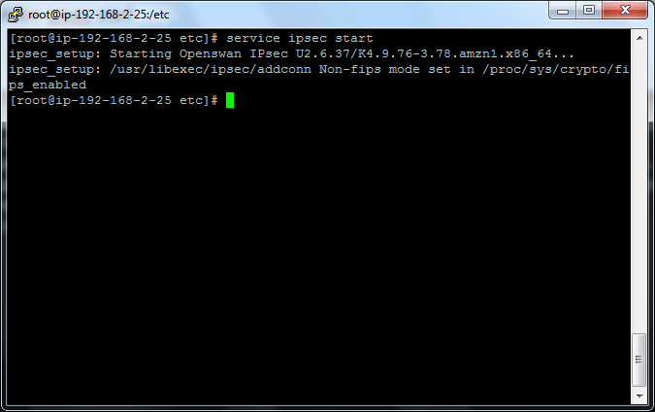

Type

Vi sysctl.conf

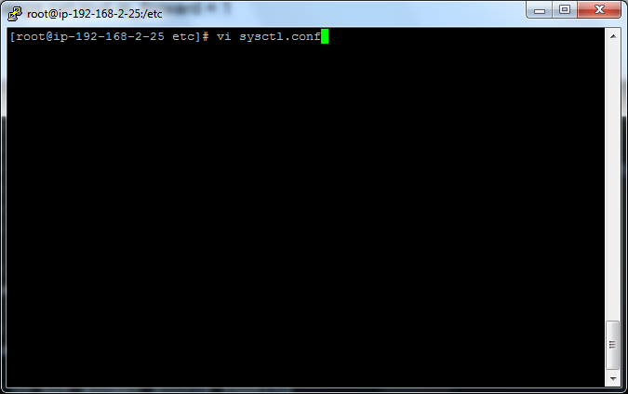

Press insert key and rename the net.ipv4.ip_forward = 1.

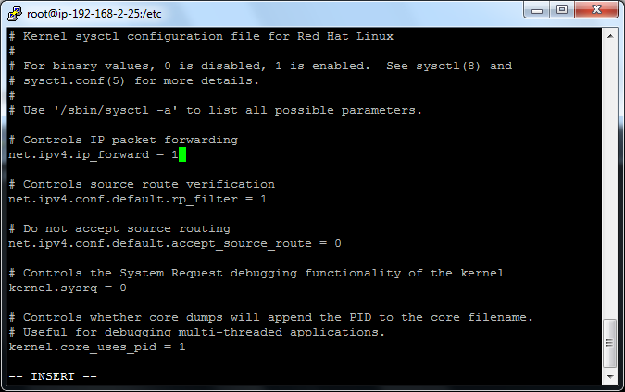

Press escape key.

Type

:wq

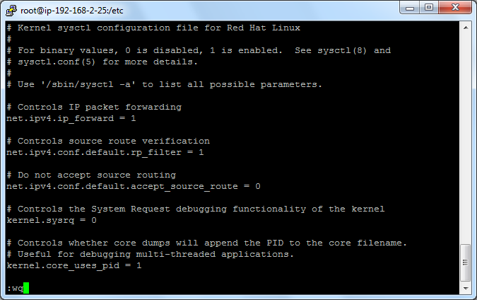

Go to Ec2 Dashboard

Click “Network interface” and then select “OpenSwan”

Click “Actions” 🡪 Click “Change source/destination check”

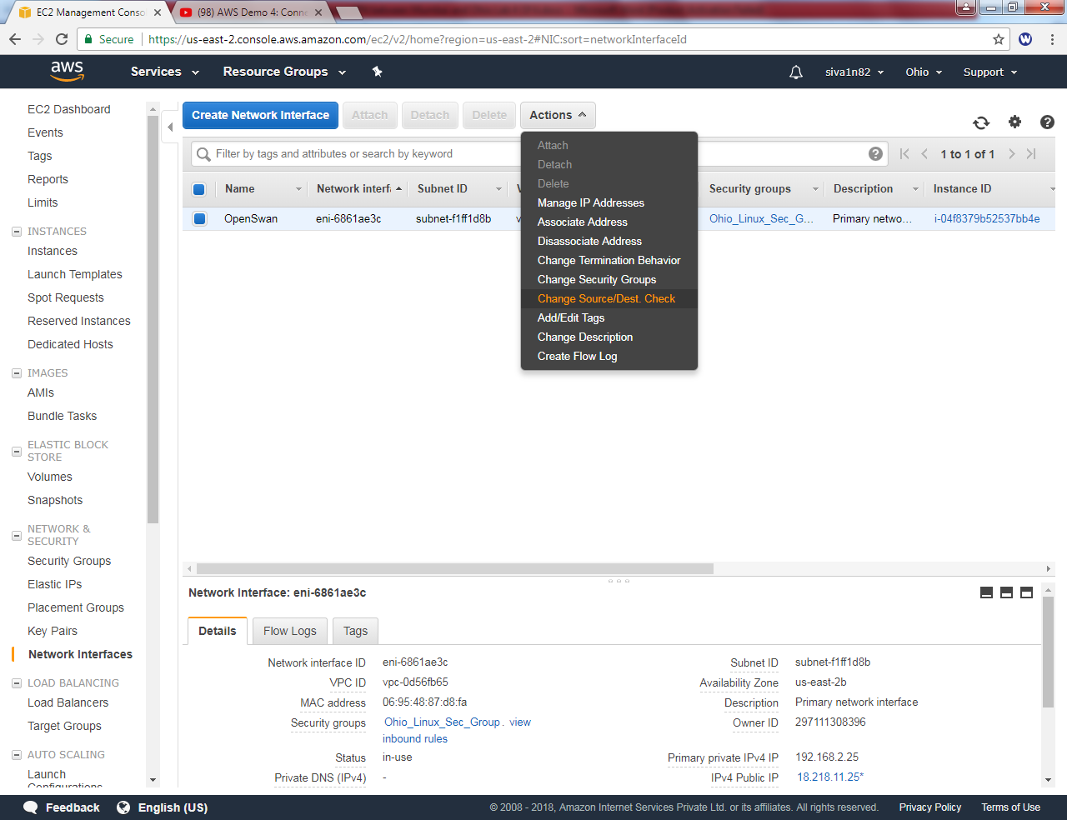

Set as “Disabled”and click “save”.

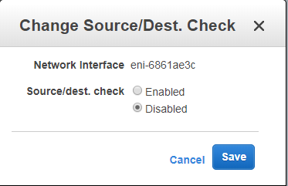

Type

Service network restart

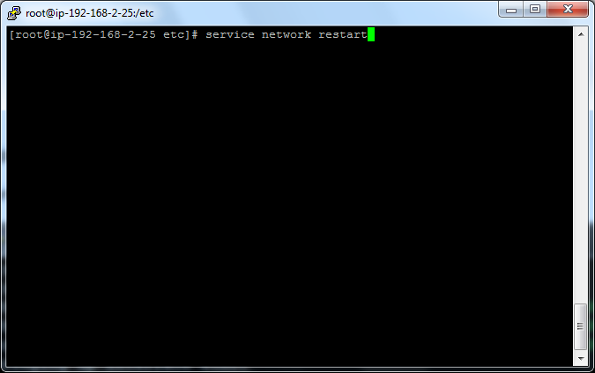

Type

Vi sysctl.conf

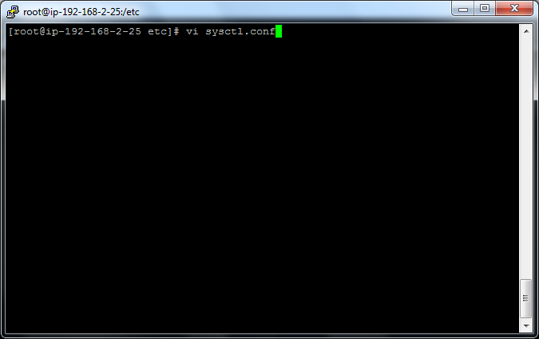

Press insert key

net.ipv4.conf.all.accept_redirects = 0

net.ipv4.conf.all.send_redirects = 0

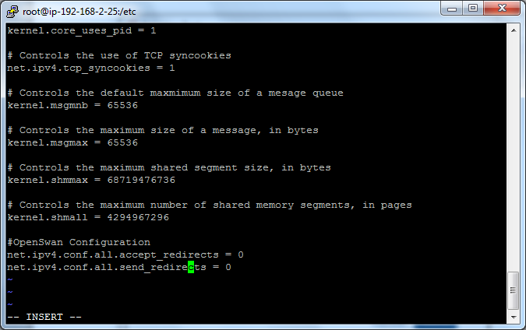

Press escape key and then type

:wq

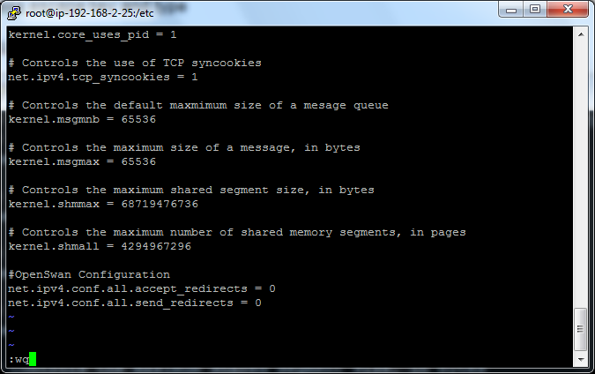

Type

Service network restart

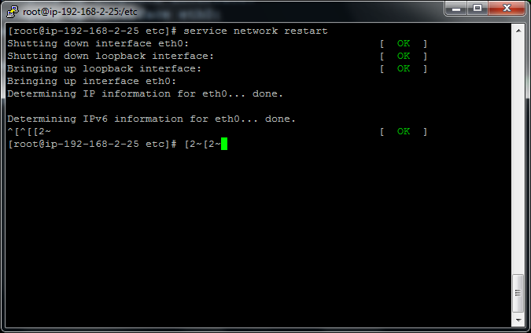

Type chkconfig ipsec on

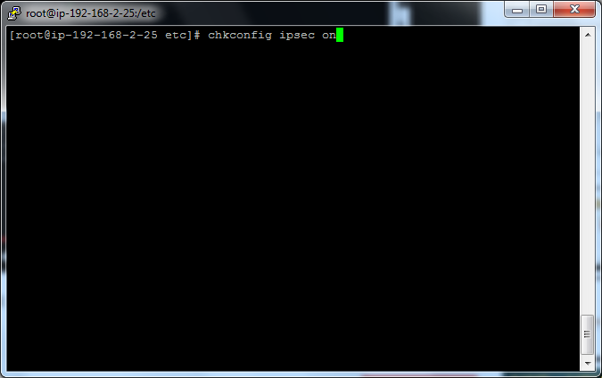

Go to VPC,

Click Route table and select sansbound public route table.

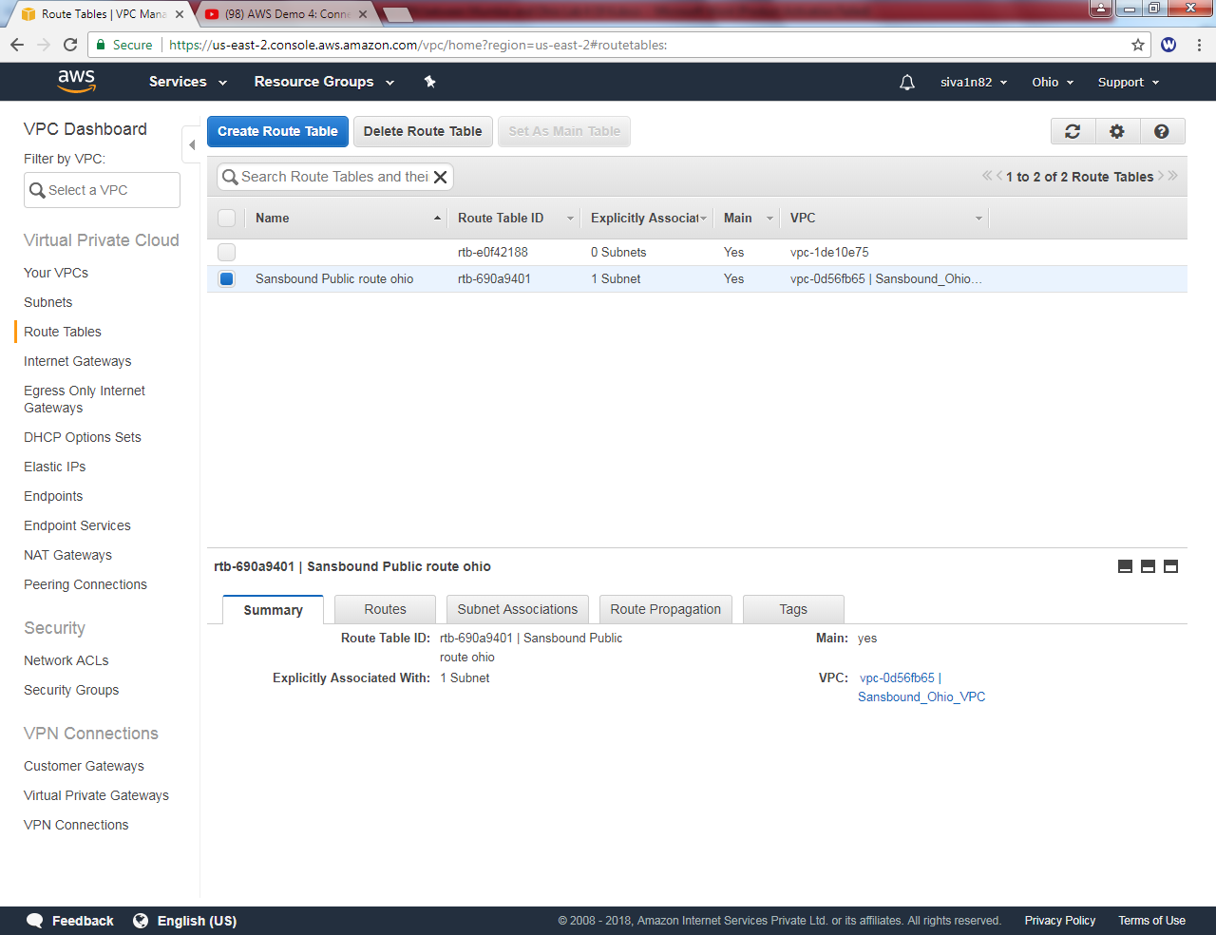

Click “Edit”.

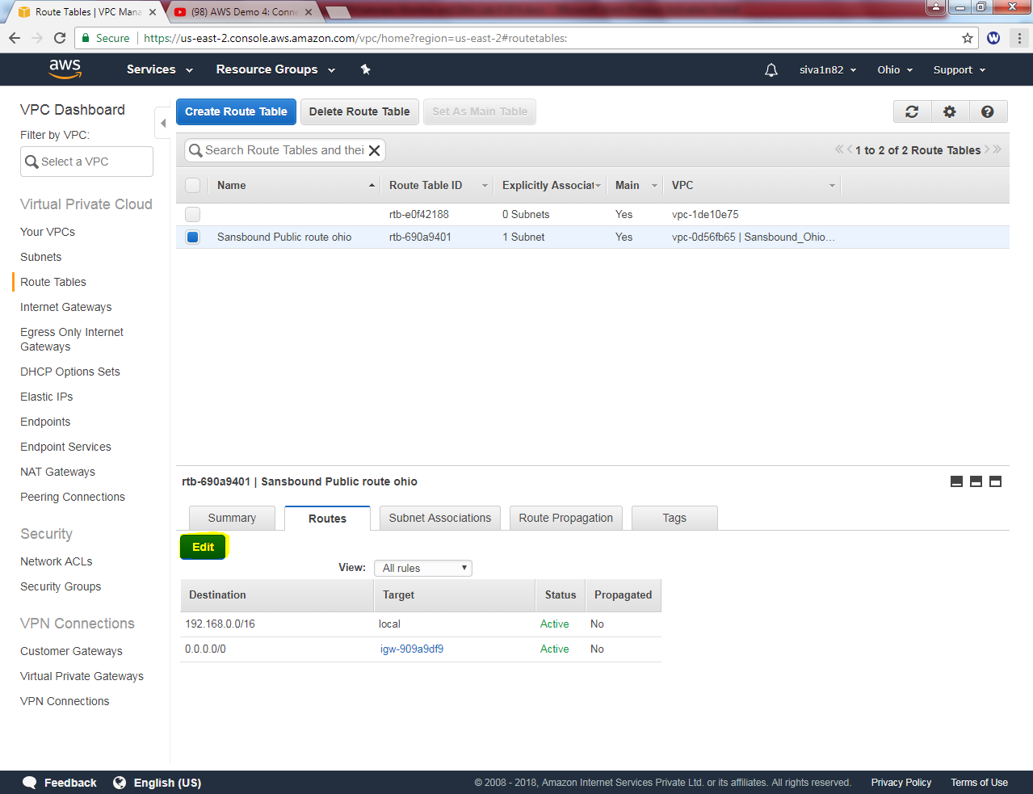

Click “add another route”.

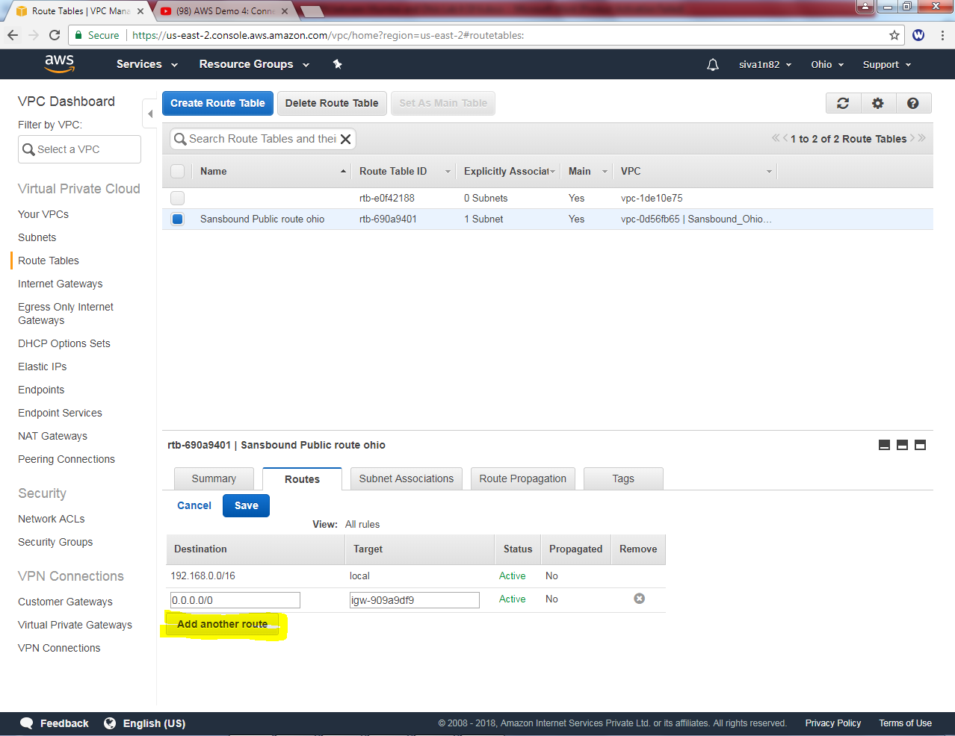

Type 10.0.0.0/16 subnet as destination and select “VPN Linux Server” as target.

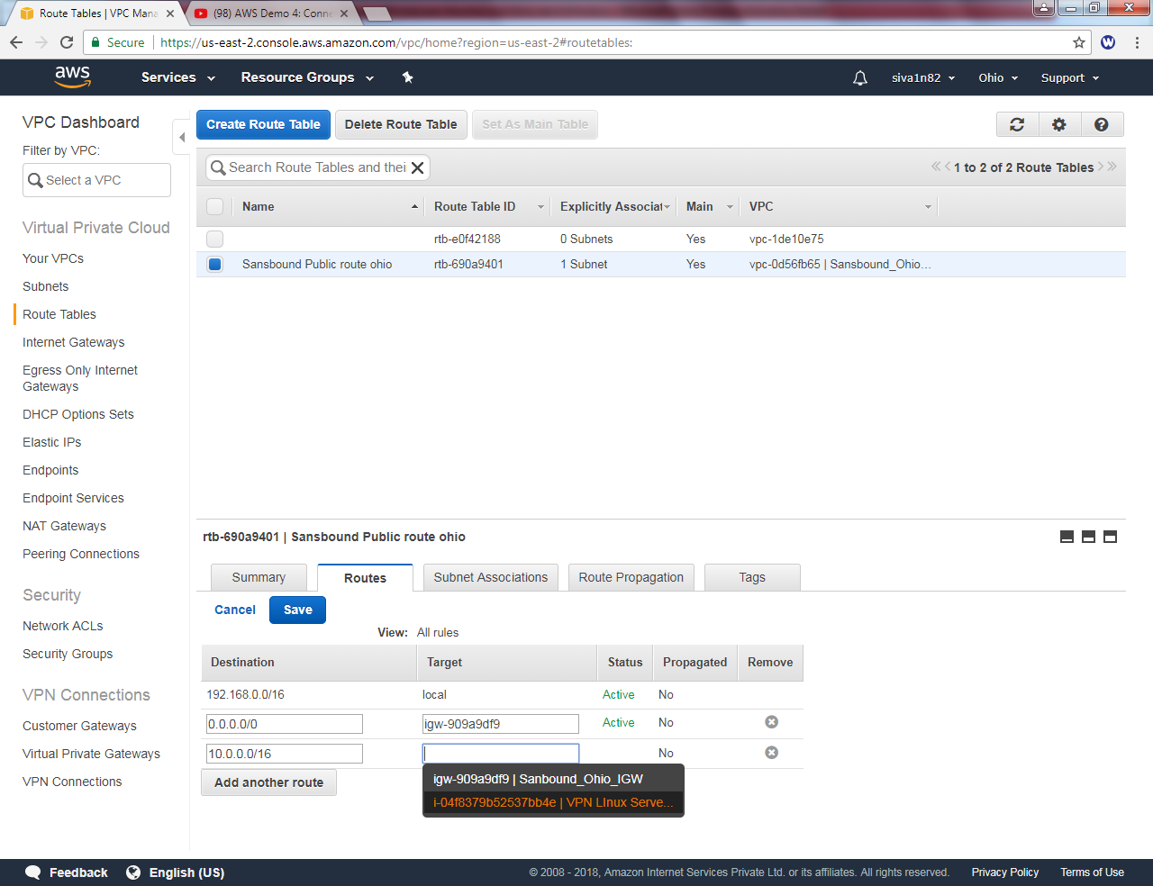

Click “save”.

Click To view detailed information of routing table as below.

